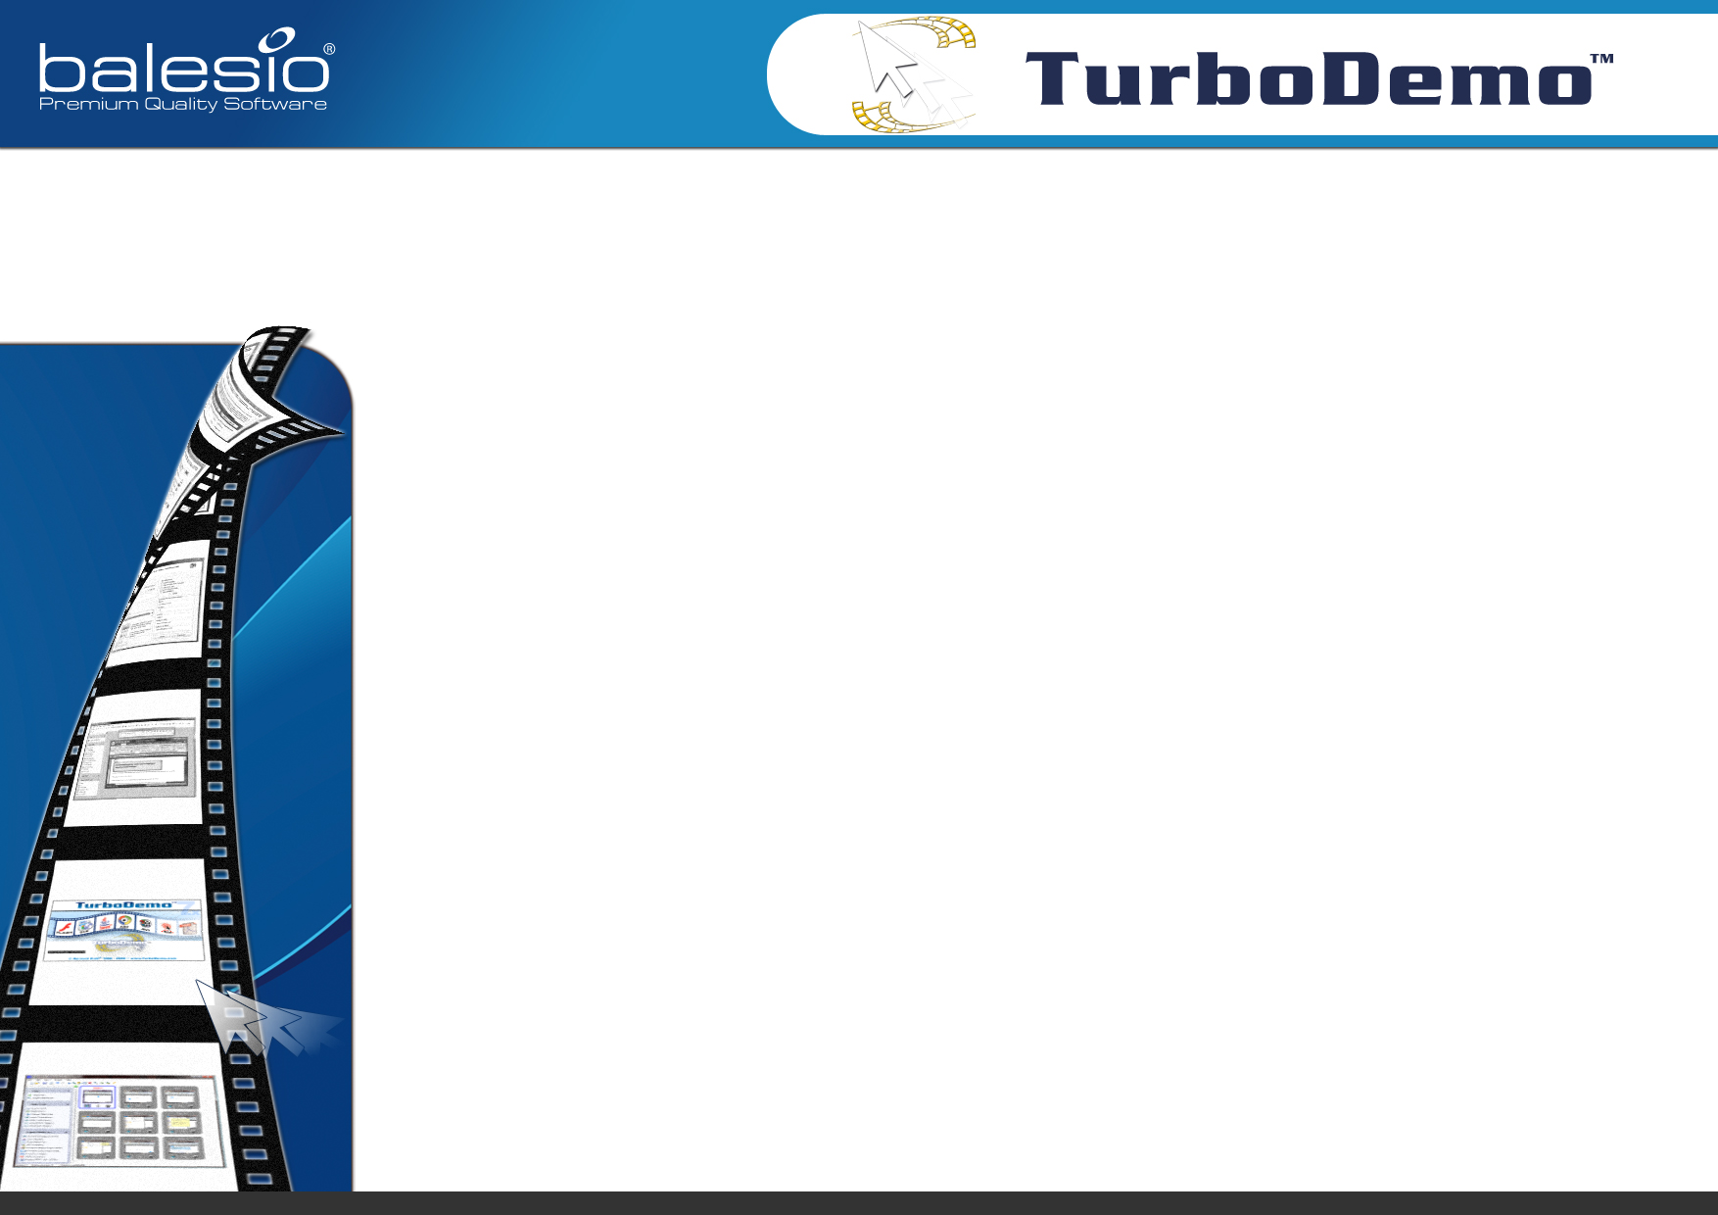
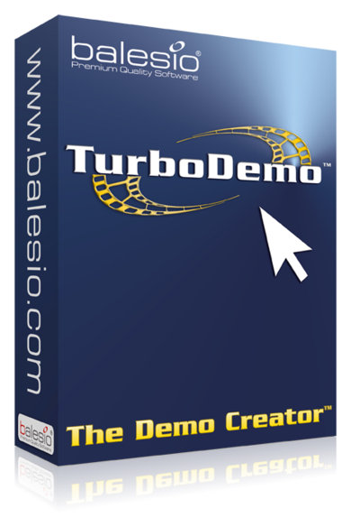
More information is available from your local reseller:

Why TurboDemo is what you need:
- Create great looking marketing and sales presentations in Flash and other formats
- Create interactive e-learning courses and tutorials (with click areas, quizzes & SCORM)
- IT and Training: create help tutorials, interactive FAQs and professional support
- Easy to use: create a demo in 10-15 minutes
- Compressed, small files: shorter loading time, ideal for Internet use
- Export in 7 different output formats: Flash, Java, EXE, GIF, ASF also Word and PDF
for documentation
- No installation required: also runs directly from CD
- Simultaneous recording of on-screen activities and sound
- No programming knowledge required
- Insert, add, delete and duplicate slides
- Customize slide duration
- Optimized for PCs with multi-core processors

Capture screenshots and explain software, PC applications, websites and products with animated slide-per-slide demos and tutorials.
TurboDemo is a professional software tool, which allows for the easy demonstration of applications, processes, websites or anything displayed on a monitor. Simply capture the screen, edit the project and export it. Create in minutes professional online and offline demos or e-learning tutorials with TurboDemo. The created demo files are small and ideal for the Internet. TurboDemo: the most effective way to demonstrate software, PC applications, processes or websites.
2009 © Copyright - All rights reserved balesio AG - Premium Quality Software

